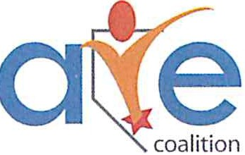
C
MEMORANDUM OF UNDERSTANDING

CARE Coalition - 1919 S Jones Blvd. Suite A Las Vegas, NV 89146
This Memorandum of Understanding (hereinafter referred to as MOU) is between, the CARE Coalition and .Whereas, both parties are committed to the awareness and prevention of substance abuse in Clark County, Nevada.

It is understood in this agreement that agrees to the following:
- Agree to work with the CARE Coalition in its efforts to provide prevention services and substance abuse awareness in Clark County.
- Attend at least 50% of the monthly coalition meetings and activities.
- Raise awareness in Clark County to support the CARE Coalition.

The CARE Coalition, under this agreement, will do the following:
- Share information and data obtained through the implementation of projects, as well as lessons learned, with Coalition Members.
- Coordinate services with each participating entity to ensure non-duplication of service and effective case management where clients participate in services provided by more than one entity.
- Participate in partnership meetings and events when possible.
- Raise awareness and support community partners.
- Take action on items agreed on by the coalition.
- Operate with integrity.

This Memorandum of Understanding is effective upon signature and shall terminate one year from the signed date, unless renewed by mutual agreement. It is also understood by all parties that either party can cancel this agreement for any violation to this agreement, by written notification.

Participants Name/Agency Community Sector

Participants Contact Information;
Address, phone #, email
Date

Diane Anderson, Executive Director Date

